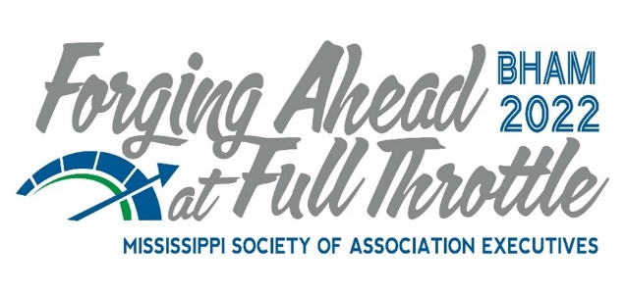
2022 MSAE Industry Partner Registration and Sponsorships
All Sponsorships Are Exclusive (Except Where Noted)
_______ $575 Includes registration and networking table**
_______ $250 Second person, same company/organization
Show times: Sunday, November 6th: 5:00pm – 6:30 pm Opening Reception with door prizes from each company with networking table**
(All Sponsorships and other Opportunities are in addition to the registrations listed above.)
Diamond Sponsorships: $1,700 members*
Choose one:
______ National Speaker, Scotty Sanders – Monday General Session and Monday Breakout Session – Introduce speaker after a 3–5-minute sponsor welcome at General Session and introduce speaker at Breakout Session, banner may be placed in front of room.
______ Dinner at Barber Museum
______ Tuesday Brunch & Send-off Sponsor
Ruby Sponsorship: $1,250*
Choose One:
_____ Welcome Gift Sponsor
_____ Fries with That Shake Break (Sunday) – Homemade Chocolate and Vanilla Shake with Home Fries
_____ Beverage/Bar Sponsor Opening Night Networking Reception
_____ Bloody Mary/Mimosa Break (Monday)
_____ Beverage/Bar Sponsor Closing Night Party Bar Sponsor
Sapphire Sponsorships: $950*
Choose from one of the following activities:
_____ Opening Night Entertainment Sponsor
_____ Monday Breakfast Sponsor
_____ Monday Grab & Go Lunch Sponsor
_____ Barber Museum Entertainment Sponsor
Emerald Sponsorships $800*
_____ Opening Session $500 Grand Cash Prize Sponsor
_____ Closing Session $500 Grand Cash Prize Sponsor

Cash Prize Sponsor $400
_____ Pop-up Cash Prizes (multiple available)

Turn Down Favors $200
_____ Turn-down favors (multiple available) Gifts provided by the sponsor will be placed in Executive attendee Hotel rooms at Ross Bridge on Monday night

Printed Program Advertising:
_____ $325 Inside Front Cover
_____ $325 Inside Back Cover
_____ $225 Full Page Color
_____ $100 Half page Color
*All sponsorships include:
**One property per networking space. Please email awilson@msae-net.org with any questions.
***All pricing listed above is for MSAE members only. Non-members, add $500.
Please note ALL registrations received after October 28th will incur a $50 late fee.
Contact us with any issues or questions. Phone: 601-707-7882 or email awilson@msae-net.org
---
Optional Afternoon Activities
PRE-CONVENTION ACTIVITY (Nov. 5th)
- Christmas Village Festival – $30
DAY 2 AFTERNOON ON YOUR OWN ACTIVITIES (Nov. 7th)
- Homewood Scavenger Hunt – $30
- Autobahn Indoor Speedway – $60
- Hammer & Stain Birmingham DIY Workshop – price TBD
---
Industry Partners Hotel Information:
MSAE Fall Conference - PARTNERS
Start Date: Saturday, November 5, 2022
End Date: Tuesday, November 8, 2022
Last Day to Book: Monday, October 10, 2022
Hotel(s) offering your special group rate:
• Renaissance Birmingham Ross Bridge Golf Resort & Spa for $169 per night
Book your group rate for MSAE Fall Conference - PARTNERS

